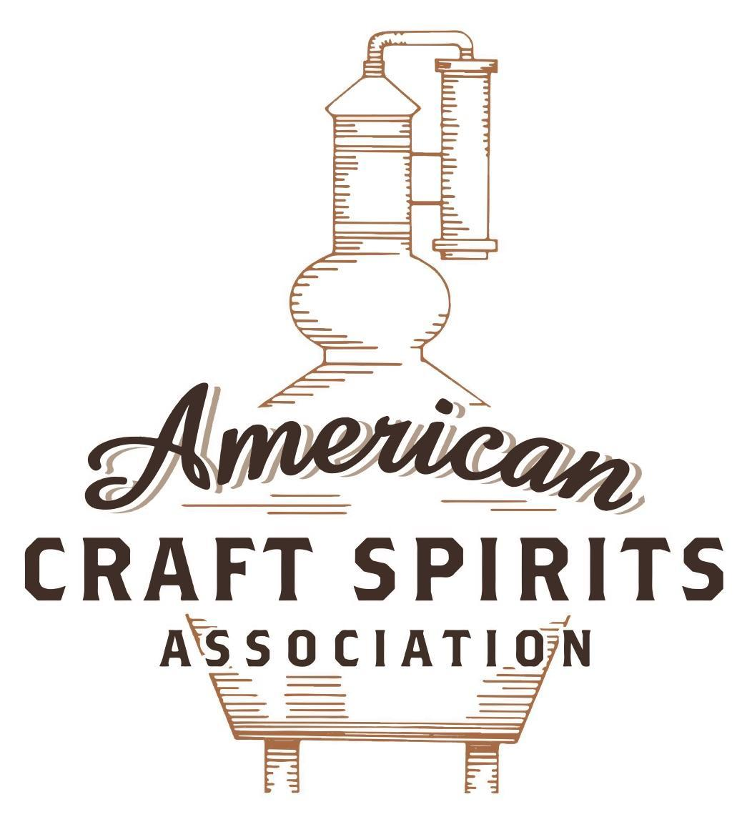
Spirits DtC Shipping Guide

This guide summarizes the direct-to-consumer shipping rules for distilleries in all 50 states and D.C. and also addresses the measures state governments have taken to ease delivery and shipping restrictions during the COVID-19 pandemic.

DtC Quick Guide Comparison

Out-of-State Distilleries  Can Ship Into State? |  |  |  | In-State Distilleries  Can Ship Within State?
State | Yes | No |  | State | Yes | No
AL |  | X |  | AL |  | X
AK | X |  |  | AK | X
AZ | X |  |  | AZ | X
AR |  | X |  | AR |  | X
CA |  | X* |  | CA |  | X*
CO |  | X |  | CO |  | X
CT |  | X* |  | CT |  | X
DE |  | X |  | DE |  | X
DC | X |  |  | DC | X
FL |  | X |  | FL |  | X
GA |  | X |  | GA |  | X
HI |  | X* |  | HI |  | ?*
ID |  | X |  | ID |  | X
IL |  | X* |  | IL |  | X*
IN |  | X |  | IN |  | X
IA |  | X* |  | IA |  | X*
KS |  | X |  | KS |  | X
KY | X |  |  | KY | X
LA |  | X |  | LA |  | X
ME |  | X* |  | ME |  | X*
MD |  | X |  | MD |  | X
MA |  | X |  | MA |  | X
MI |  | X |  | MI |  | X
MN |  | X |  | MN |  | X
MS |  | X |  | MS |  | X
MO |  | X |  | MO |  | X
MT |  | X |  | MT |  | X
NE | X |  |  | NE | X
NV |  | X* |  | NV |  | X
NH | X |  |  | NH |  | X*
NJ |  | X* |  | NJ |  | X*
NM |  | X |  | NM |  | X
NY |  | X* |  | NY |  | X*
NC |  | X |  | NC |  | X
ND | X |  |  | ND | X
OH |  | X |  | OH |  | X
OK |  | X |  | OK |  | X
OR |  | X |  | OR | X
PA |  | X* |  | PA |  | X
RI |  | X* |  | RI |  | X
SC |  | X |  | SC |  | X
SD |  | X |  | SD |  | X
TN |  | X |  | TN |  | X
TX |  | X |  | TX |  | X
UT |  | X |  | UT |  | X
VT |  | X |  | VT |  | X
VA |  | X |  | VA |  | X
WA |  | X* |  | WA | X
WV |  | X* |  | WV |  | X*

WI |  | X |  | WI |  | X
WY |  | X |  | WY |  | X

Notes:
*CA: If passed and signed into law, Senate Bill 620 would allow licensed distilled spirits producers in states other than California and licensed distilled spirits manufacturers or craft distillers in California who obtain distilled spirits direct shipper permits to ship directly to consumers in California
*CT: Consumers with appropriate permit may receive alcohol shipments
*HI: Consumers with appropriate permit may receive alcohol shipments; If passed and signed into law, Senate Bill 65 would allow licensed distilled spirits manufacturers in Hawaii and in states other than Hawaii who obtain direct shipper permits to ship directly to consumers in Hawaii
*IL: If passed and signed into law, Senate Bill 0532 would allow licensed distilled spirits producers in Illinois and in states other than Illinois who obtain distillery shippers’ licenses to ship directly to consumers in Illinois
*IA: If passed and signed into law, House File 639 would allow native distilled spirits manufacturers in Iowa and in states other than Iowa who obtain direct shipper permits to ship directly to consumers in Iowa and to consumers in states other than Iowa
*ME: If passed and signed into law, Legislative Document 1358 would allow distilleries outside of Maine with current manufacturer licenses and distilleries licensed in Maine who obtain spirits direct shipper licenses to ship directly to consumers in Maine
*NJ: (1) If passed and signed into law, Assembly Bill 3167 would allow a craft distillery licensees to ship no more than 9 liters of distilled spirits to a consumer in New Jersey; (2) If passed and signed into law, Senate Bill 3020 would allow craft distillery licensees in New Jersey or in states other than New Jersey to ship no more than 20 liters of distilled spirits to a consumer in New Jersey via common carrier
*NV: Licensed individuals can import one gallon per month of spirits for personal use and the out-of-state supplier must pay excise tax
*NH: If passed and signed into law, Senate Bill 125 would allow licensed liquor manufacturers who obtain direct to consumer shipping permits from the commission to ship directly to consumers in New Hampshire
*NY: Consumer may import up to 90L of liquor per year for personal use without a license; If passed and signed into law, Assembly Bill 3275 would allow licensed liquor manufacturers in states other than New York and licensed distillers and farm distillers in New York to ship no more than thirty-six cases (no more than nine liters per case) of liquor to consumers in New York
*PA: Consumer may place a special liquor order and distiller must ship to a PLCB-operated store
*RI: Distiller can only ship to customer if order was personally placed by customer at distiller's premises
*WA: If passed and signed into law, House Bill 1432 would allow licensed spirits manufacturers in states other than Washington to ship spirits to consumers in Washington
*WV: Distilleries, mini-distilleries, or micro-distilleries licensed in West Virginia or a state other than West Virginia who obtain private direct shipper licenses to ship to a consumer in West Virginia, however the shipments must be made to a retail liquor outlet

WASHINGTON

Shipment Outbound – Yes (RCW 66.20.410; WAC 314-28-100).
Shipment Inbound – No, out-of-state distilleries must receive a certificate of approval and distiller COAs allow distillers to sell to distributors, importers, or directly to retailers, but not consumers (WAC 314-23-030).
Shipment Intra-state – Yes (RCW 66.20.410; WAC 314-28-100).
COVID-19 Measures – Temporary provisions have allowed for to-go mixed drinks, curbside pickup/delivery, and full bottle sales from on-premise accounts. H.B. 1480, signed and enacted into law on April, 14, 2021, allows distilleries to sell alcohol products at retail for curbside service, takeout, and delivery through July 1, 2023.
Link: https://content.govdelivery.com/bulletins/gd/WALCB-28a1611?wgt_ref=WALCB_WIDGET_1
H.B. 1480 Link: http://lawfilesext.leg.wa.gov/biennium/2021-22/Pdf/Bills/House%20Passed%20Legislature/1480-S2.PL.pdf
Citation (shipment)
Washington Revised Code
RCW 66.20.410 Distillery orders for spirits.
(1) The holder of a license to operate a distillery or craft distillery issued under RCW 66.24.140 or 66.24.145 may accept orders for spirits from, and deliver spirits to, customers if all of the following conditions are met for each sale:
(a) Spirits are not used for resale;
(b) Spirits come directly from the distillery's or craft distillery's possession prior to shipment or delivery. All transactions are to be treated as if they were conducted in the retail location of the distillery or craft distillery regardless of how they are received or processed;
(c) Spirits may be ordered in person at a licensed location, by mail, telephone, or internet, or by other similar methods; and
(d) Only a distillery or craft distillery licensee or a licensee's direct employees may accept and process orders and payments. A contractor may not do so on behalf of a distillery or craft distillery licensee, except for transmittal of payment through a third-party service. A third-party service may not solicit customer business on behalf of a distillery or craft distillery licensee.
(2) All orders and payments must be fully processed before spirits transfers ownership or, in the case of delivery, leaves a licensed distillery's or craft distillery's possession.
(3) Payment methods include, but are not limited to: Cash, credit or debit card, check or money order, electronic funds transfer, or an existing prepaid account. An existing prepaid account may not have a negative balance.
(4) To sell spirits via the internet, a new distillery or craft distillery license applicant must request internet-sales privileges in his or her application. An existing distillery or craft distillery licensee must notify the board prior to beginning internet sales. A corporate entity representing multiple licensees may notify the board in a single letter on behalf of affiliated distillery or craft distillery licensees, as long as the liquor license numbers of all licensee locations utilizing internet sales privileges are clearly identified.
(5) Delivery may be made only to a residence or business that has an address recognized by the United States postal service; however, the board may grant an exception to this rule at its discretion. A residence includes a hotel room, a motel room, marina, or other similar lodging that temporarily serves as a residence.
(6) Spirits may be delivered each day of the week between the hours of 6:00 a.m. and 2:00 a.m. Delivery must be fully completed by 2:00 a.m.
(7) Under chapter 66.44 RCW, any person under twenty-one years of age is prohibited from purchasing, delivering, or accepting delivery of liquor.
(a) A delivery person must verify the age of the person accepting delivery before handing over liquor.
(b) If no person twenty-one years of age or older is present to accept a liquor order at the time of delivery, the liquor must be returned.
(8) Delivery of liquor is prohibited to any person who shows signs of intoxication.
(9)(a) Individual units of spirits must be factory sealed in bottles. For the purposes of this subsection, "factory sealed" means that a unit is in one hundred percent resalable condition, with all manufacturer's seals intact.
(b) The outermost surface of a liquor package, delivered by a third party, must have language stating that:
(i) The package contains liquor;
(ii) The recipient must be twenty-one years of age or older; and
(iii) Delivery to intoxicated persons is prohibited.
(10)(a) Records and files must be retained at the licensed premises. Each delivery sales record must include the following:
(i) Name of the purchaser;
(ii) Name of the person who accepts delivery;
(iii) Street addresses of the purchaser and the delivery location; and
(iv) Time and date of purchase and delivery.
(b) A private carrier must obtain the signature of the person who receives liquor upon delivery.
(c) A sales record does not have to include the name of the delivery person, but it is encouraged.
(11) Web site requirements. When selling over the internet, all web site pages associated with the sale of liquor must display the distillery or craft distillery licensee's registered trade name.
(12) A distillery or craft distillery licensee is accountable for all deliveries of liquor made on its behalf.
(13) The board may impose administrative enforcement action upon a licensee, or suspend or revoke a licensee's delivery privileges, or any combination thereof, should a licensee violate any condition, requirement, or restriction.
Link: https://app.leg.wa.gov/RCW/default.aspx?cite=66.20.410
WAC 314-28-100 Link: https://apps.leg.wa.gov/wac/default.aspx?cite=314-28-100
Washington Administrative Code
WAC 314-23-030 What does a spirits certificate of approval license allow?
(1) A spirits certificate of approval license may be issued to spirits manufacturers located outside of the state of Washington but within the United States.
(2) There are three separate spirits certificate of approval licenses as follows:
(a) A holder of a spirits certificate of approval may act as a distributor of spirits they are entitled to import into the state by selling directly to spirits distributors or spirits importers licensed in Washington state. The fee for a certificate of approval is two hundred dollars per year.
(b) A holder of an authorized representative out-of-state spirits importer or brand owner for spirits produced in the United States but outside of Washington state may obtain a spirits authorized representative domestic certificate of approval license which entitles the holder to import spirits into the state by selling directly to spirits distributors, or spirits importers licensed in Washington state. The fee for an authorized representative certificate of approval for spirits is two hundred dollars per year.
(c) A holder of an authorized representative out-of-state spirits importer or brand owner for spirits produced outside of the United States obtains a spirits authorized representative foreign certificate of approval which entitles the holder to import spirits into the state by selling directly to spirits distributors, or spirits importers licensed in Washington state. The fee for an authorized representative certificate of approval for foreign spirits is two hundred dollars per year.
(3) A spirits certificate of approval holder, a spirits authorized representative domestic certificate of approval holder, and/or a spirits authorized representative foreign certificate of approval holder must obtain an endorsement to the certificate of approval that allows the shipment of spirits the holder is entitled to import into the state directly to licensed liquor retailers. The fee for this endorsement is one hundred dollars per year and is in addition to the fee for the certificate of approval license.
Link: https://apps.leg.wa.gov/wac/default.aspx?cite=314-23-030&pdf=true

WAC 314-28-100 Consumer orders, internet sales, and delivery for distillery and craft distillery licensees.
A distillery or craft distillery licensee may accept orders for spirits from, and deliver spirits to, customers.
(1) Resale. Spirits shall not be for resale.
(2) Stock location. Spirits must come directly from a licensed distillery or craft distillery possession.
(3) How to place an order. Spirits may be ordered in person at a licensed location, by mail, telephone, or internet, or by other similar methods.
(4) Sales and payment.
(a) Only a spirits distillery or craft distillery licensee or a licensee's direct employees may accept and process orders and payments. A contractor may not do so on behalf of a spirits distillery or craft distillery licensee, except for transmittal of payment through a third-party service.
The use of internet or mobile applications for retail customers to purchase alcohol in Washington state are allowed under the following conditions:
(i) The internet sale will be made by the distillery;
(ii) The payment for the sale will be processed by the distillery; and
(iii) The distillery pays the owner of the internet or mobile application a service fee.
(b) All orders and payments shall be fully processed before spirits transfers ownership or, in the case of delivery, leaves a licensed distillery's possession.
(c) All orders and payments shall be fully processed before spirits transfers ownership or, in the case of delivery, leaves a licensed distillery's or craft distillery's possession.
(d) Payment method. Payment methods include, but are not limited to: Cash, credit or debit card, check or money order, electronic funds transfer, or an existing prepaid account. An existing prepaid account may not have a negative balance.
(e) Internet. To sell spirits via the internet, a new spirits distillery or craft distillery license applicant must request internet sales privileges in his or her application. An existing spirits distillery or craft distillery licensee must notify the board prior to beginning internet sales. A corporate entity representing multiple stores may notify the board in a single letter on behalf of affiliated spirits distillery or craft distillery licensees, as long as the liquor license numbers of all licensee locations utilizing internet sales privileges are clearly identified.
(5) Delivery location. Delivery shall be made only to a residence or business that has an address recognized by the United States postal service; however, the board may grant an exception to this rule at its discretion. A residence includes a hotel room, a motel room, or other similar lodging that temporarily serves as a residence.
(6) Hours of delivery. Spirits may be delivered each day of the week between the hours of 6:00 a.m. and 2:00 a.m. Delivery must be fully completed by 2:00 a.m.
(7) Age requirement.
(a) Under chapter 66.44 RCW, any person under twenty-one years of age is prohibited from purchasing, delivering, or accepting delivery of liquor.
(b) A delivery person must verify the age of the person accepting delivery before handing over liquor.
(c) If no person twenty-one years of age or older is present to accept a liquor order at the time of delivery, the liquor shall be returned.
(8) Intoxication. Delivery of liquor is prohibited to any person who shows signs of intoxication.
(9) Containers and packaging.
(a) Individual units of spirits must be factory sealed in bottles. For the purposes of this subsection, "factory sealed" means that a unit is in one hundred percent resalable condition, with all manufacturer's seals intact.
(b) The outermost surface of a liquor package, delivered by a third party, must have language stating that:
(i) The package contains liquor;
(ii) The recipient must be twenty-one years of age or older; and
(iii) Delivery to intoxicated persons is prohibited.
(10) Required information.
(a) Records and files shall be retained at the licensed premises. Each delivery sales record shall include the following:
(i) Name of the purchaser;
(ii) Name of the person who accepts delivery;
(iii) Street addresses of the purchaser and the delivery location; and
(iv) Time and date of purchase and delivery.
(b) A private carrier must obtain the signature of the person who receives liquor upon delivery.
(c) A sales record does not have to include the name of the delivery person, but it is encouraged.
(11) Website requirements. When selling over the internet, all website pages associated with the sale of liquor must display the spirits distillery or craft distillery licensee's registered trade name.
(12) Accountability. A spirits distillery or craft distillery licensee shall be accountable for all deliveries of liquor made on its behalf.
(13) Violations. The board may impose administrative enforcement action upon a licensee, or suspend or revoke a licensee's delivery privileges, or any combination thereof, should a licensee violate any condition, requirement, or restriction.
Link: https://apps.leg.wa.gov/wac/default.aspx?cite=314-28-100

The American Craft Spirits Association (ACSA) is working diligently to give our members and industry partners relevant, current updates on statutes and regulations impacting production, sale and distribution of spirits. With the declaration of the novel coronavirus (COVID-19) in early 2020, many states have issued temporary policy changes or longer-term modernization of alcohol beverage laws. State statutes, regulations created by the state alcohol regulatory authority, as well as any other relevant guidance provided by such authorities (such as advisories, opinions, bulletins, etc.) were reviewed in creation of this document. No city or county ordinances were reviewed. Distillers should be aware that even in states where direct shipping is permissible, always remember to avoid shipping to dry counties. Please consult with your state guild or alcohol beverage authority for the most up-to-date information. This content is intended for educational and informational purposes only. ACSA's pro bono law firm of Malkin Law P.A. provided the core content found in this comprehensive overview of the spirits distribution after COVID-19. It was completed in August 2021 and will be updated regularly. If you have updates you would like to provide, please send to legislation@americancraftspirits.org or directly to the law firm at: ryan@malkin.law / malkin.law. Thank you.
H.B. 1432, introduced on January 1, 2021, would allow a holder of a license to manufacturer spirits issued by another state or a holder of a certificate of approval license issued by another state to ship spirits that the license holder is allowed to manufacture or import to a consumer in Washington who is at least 21 years of age for personal use. The bill is in committee. Link: http://lawfilesext.leg.wa.gov/biennium/2021-22/Pdf/Bills/House%20Bills/1432.pdf

